1. Detail of the application: explanation
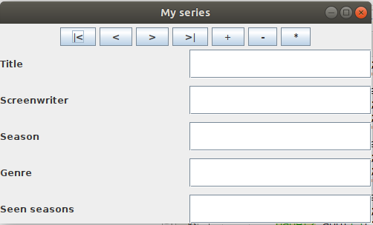
It is about making a simple graphic application to carry a list of tv series. We want to have saved the data of those series that we have seen or would like to see. We will have a file where the data will reside so that they are not lost (persistence). The program will take this data and present it in a window where we will be able to see the contents of the file but it will also allow us the typical CRUD operations (create-read-update-delete), that is, we will be able to add new series, consult existing ones, change and delete series. The finished program could look like this:

We have a view of a series and we have buttons to move through the several series that we have saved in a file (which we will call series.dat, for example) and there are also buttons to: create new series (+), delete series (-) and update the data of any series that was already entered (*)
For the realization of the program we will use object oriented programming (as it could not be otherwise today) and the design pattern of sw Model-View-Controller (MVC). Software design patterns are rules for building programs. This does not mean that programs should be done this way, but following these rules guarantees us some advantages, especially in the construction of large applications where a team of programmers intervenes and the workload must be distributed. There are many design patterns and you can apply several of them at once. The most widespread nowadays and normally used in companies is the MVC, sometimes it is used alone and other times other patterns are also applied.
Basically the MVC is based on separating the application into three components:
Model: is the part of the program that manages the data structures and guarantees the persistence of the data. This persistence can come due to the use of DBMS or, in simpler programs, using files. As we have not yet advanced enough in the data access module we will use files, later we will adapt the program to attack a database.
View: This is the part where the information is presented to the user and interacts with him. It will be a window built with Swing classes.
Controller: is the part that serves as a bridge between the model and the view.
The underlying idea in this pattern is that if you change one of the parts it should not affect the others, for example if we change the model so instead of using files you will only have to change the part of the model and the rest would remain the same.
For more detailed information on this pattern, you can consult the wikipedia entry:
https://es.wikipedia.org/wiki/Modelo%E2%80%93vista%E2%80%93controller

2. Create the project.
We are going to create a netbeans project called series, we will also create three packages within the project: model, view and controller. Our project (empty, for now) will look like this:

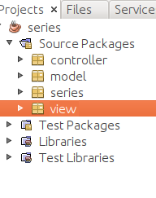

To create a new package in a project we right click on Source Packages and select New and Java Package.
In each of the packages we will have the classes to implement each part of our application. The main package or the one that NetBeans creates by default every time a project is created, in this case series, contains the main and will only serve to launch the application.
3. The model.
In the model we will create the necessary classes to deal with the data. We have to stop to think about what data we need or want to have from each series. Suppose we want to save the following data for each series:

Title: Braking Bad.
Screenwriter: Vicente Gilligan.
Seasons: 5
Genre: Comedy drama.
Seasons seen: 5.

Once we have the relevant information we want, we must see how to save the data in the series.dat file. In java we can use text files, object files, etc. As the series information has the typical structure of an object, we will opt for an object file. To use object files we have two approaches, both totally valid, the first is to save each series in the file separately, that is, we would have in the file as many objects as series we have saved. The other is to have a file that only stores one object, in this case an ArrayList (arrays are, more or less, object vectors). We will opt for the second solution. The idea will be: I create series and add them in an arraylist and then save this arraylist in the file.
We are going to build that will be the best way to understand this. We will include three classes in the model package, show, listShow and access:
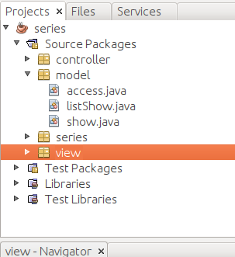

In the show class (series, in English) we will define the object that will contain the data of a class, in the listShow class we will define how the series arralist will be and the methods to work with this arrayList and access will serve to save and read the data of a file that will reside on our hard drive.
We will start with the show class, then we will do the listShow and finally the access class.

3.1. The Show class.
To create this class we will be adding all the properties that the series has:
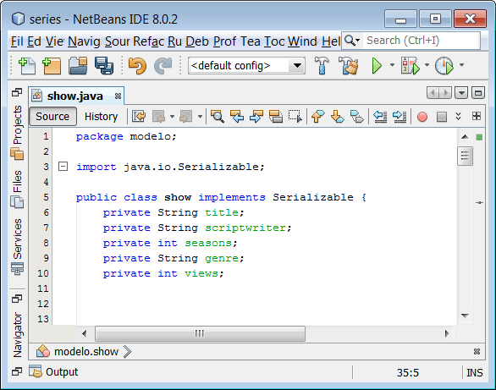

As you can see we have implemented the Serializable interface in our class, this is mandatory in order to save the objects in an object file.
Now to create the constructor of the class we use NetBeans, we click on the code with the right mouse button and select insert code:

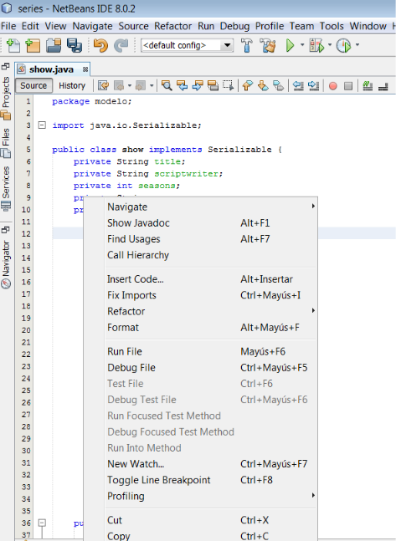

And it appears:
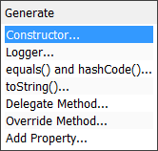

We select constructor:

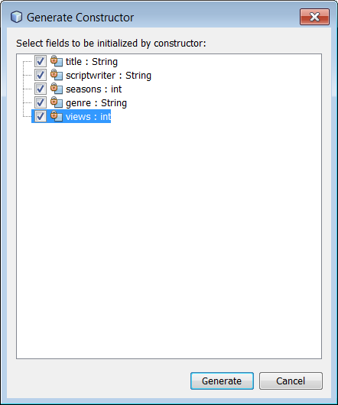

Click generate:
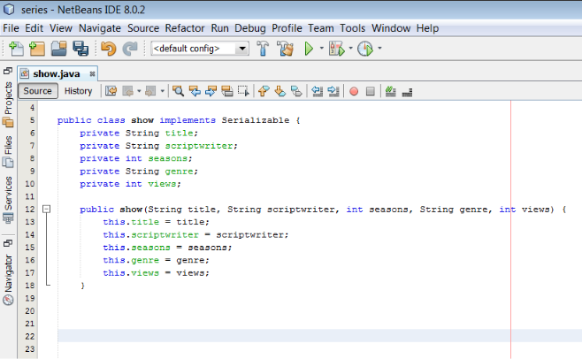

Thus generating the constructor of the class. As you know we can have several constructors, we are going to copy and paste and we will leave a second constructor that initializes the properties to empty:

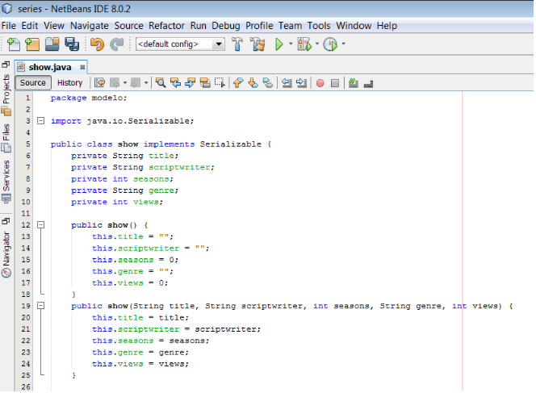

Now to create the methods that access these properties we use the code generator again:

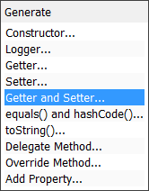

Now we select getter and setter:

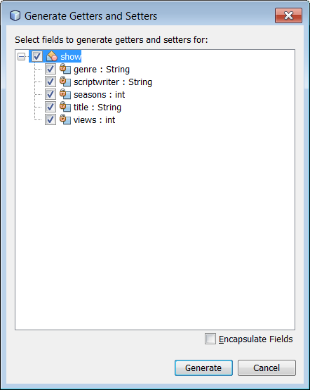

And we have:
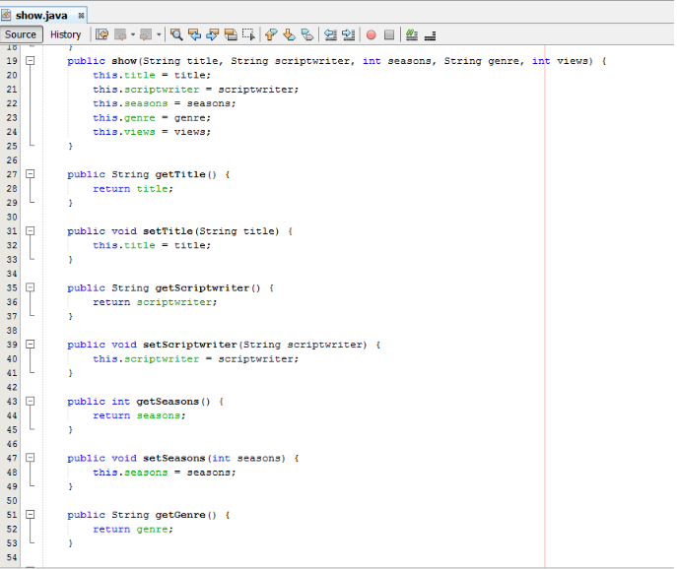
We have created the show class. This class defines the basic object that will contain the information of a string. To be able to work with many series at the same time we will use an ArrayList, we will define this in the following class listShow

3.2. The listShow class.
This class will have a property that will be an array of show type objects. We will use the methods of the ArrayList get, add and size to access our array of show objects:

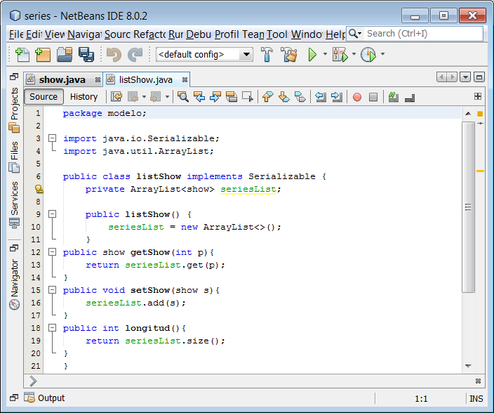

For now we have only created classes that will define how the objects that we will use in our program will be: the show class that allows us to process the data associated with a series and the listShow class that will allow us to contain the set in an ArrayList of series with which we want to work. Now we are missing a class that allows us to read the series from the file series.dat and save in that same file the things that the user has modified, we will do that in the access class.

3.3. The access class.
This class, as we have already mentioned, will be in charge of the files, we begin by declaring the file to use:
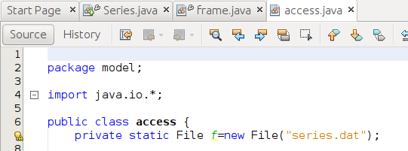

The file will be called series.dat, it can be anywhere on the hard disk, if it has no path, as in this case, it is saved in the project folder.
We will need at least two methods:
saveLS: write the data it receives as an argument to the file.
loadLS: read from the file and return the data in an arraylist.
In addition we are going to make the access class methods public and static, in this way we can call them without instantiating an object of the class, that is, they can be called:
access.loadLS ();
Let's start with saveLS, the process to write a single data to a file could be:

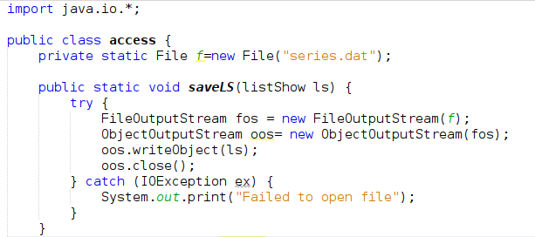

As the instantiation of the FileOutputStream has been carried out without options, only the file to be written has been passed to it, each time we write to the file all previous data will be erased. This is the behavior I want, since the file will contain only a single object (in this case that single object is an arraylist, but it is only one). In this way, every time I modify the arraylist and want to save it, I will overwrite everything there was, leaving the new arrayList updated.
Now let's see how it could be to loadLS:
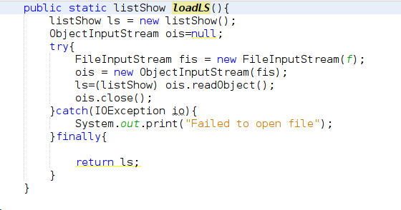

As you can see, this method reads the only arraylist from the file using the ls object and simply returns it.

3.4. Testing the model.
We have written a lot of code without proving that it will work as we intend, which is bad practice. Let's stop to check if the created classes work and are useful. Then we will continue building the rest of the parts of the application.
To test the written code we will use the series package that contains the main application. For this we will create two series, we will save them in a series arraylist and we will call the saveLS method so that they are saved in file:
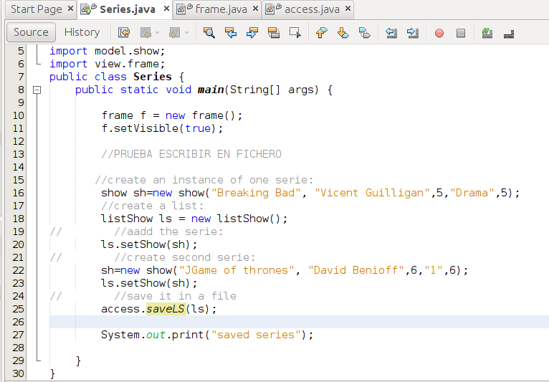

If we run the result will only be:
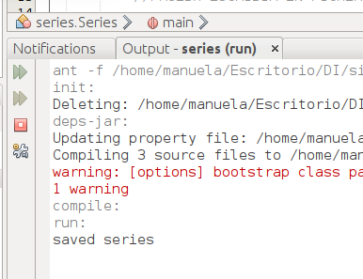

But you must have created a file in our project:
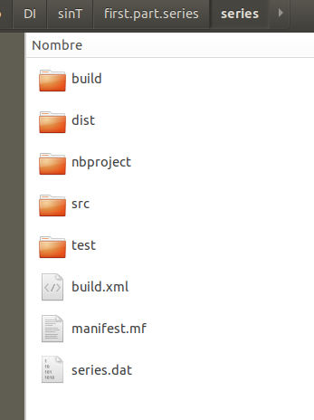

We are going to check now that we can recover the series saved in file, for this we comment on all the previous code. And we write:
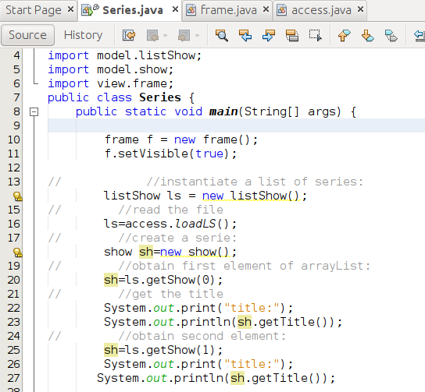

If we execute:
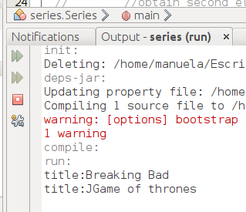

It seems, therefore, that our model works and performs the operations of reading and writing from files.

All that has been done have been operations that do not use graphic classes at all, it has been a review of access to files that is seen in depth in the first module. Next week we will do the purely user interface part: the view and the controller that bridges the view and the model.

